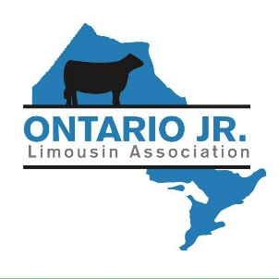

OJLA Membership Form

Year: ______________

Name:_____________________________ Birth Date:_________________________

Age as of Jan. 1st of Current Year:________________________________________________

Address:_______________________________ Town:_____________________________

Postal Code:____________________________ Province:___________________________

Phone:_________________________________ Cell Phone:_________________________

Fax:___________________________________ Email:______________________________

Parents:_______________________________________________________________________

Please circle one: New Member Returning Member

I am interested in helping with:____________________________________________________

I would like to know more about:__________________________________________________

Annual Membership Fee of $20.00 is to be paid with membership to the Ontario Jr. Limousin Association. ($40 fee after Sept. 1st.)

Please send completed form and payment to: Carolyn Darling
4172 County Rd. 25
Castleton, ON
K0K 1M0

